**HTTP status code reference:**

<https://developer.mozilla.org/en-US/docs/Web/HTTP/Status>

**rewrites and redirects or returns:**

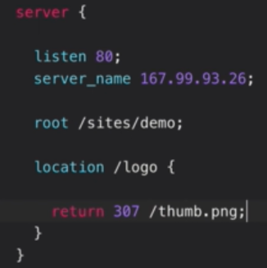

* So, when we save the configuration as above, the request even with **“/logo”** will return to the given **“/thumb.ping”** as below.

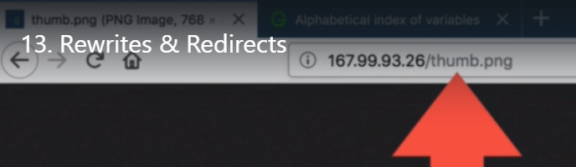

* As we see above, even if we hit the URL with **“/logo”** context, it will be redirected to **“/thumb.png”** which is the major difference between rewrites and redirects.
* A redirect simply tells the client where to go instead, even if we give wrong context as above.
* A rewrite in the other hand, mutates the URI internally.

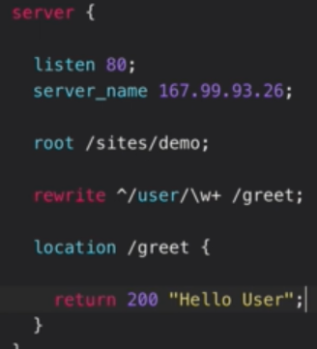

* As above, we gave rewrites. **“w+”** means that one word extra we can add in the URL.

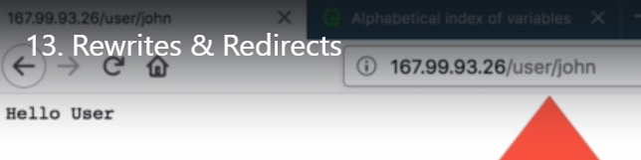

* As above, we have the context as **“/user/john”** which give the same output as returned in return as hello world. But we can see the URL doesn’t get changes as it gets changed in redirects.
* **“john”** in above URL is for the second condition in rewrite **“w+”**

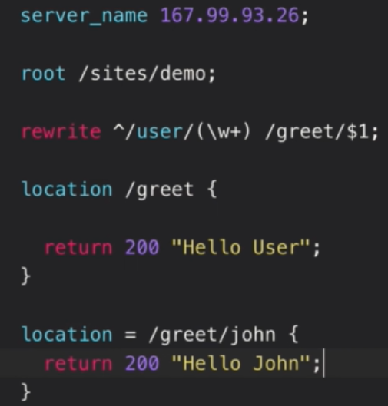

* Even if we rewrite the match as above along with the exact match. Then the priority will be for exact match, so it will print as **“hello john”** as below.

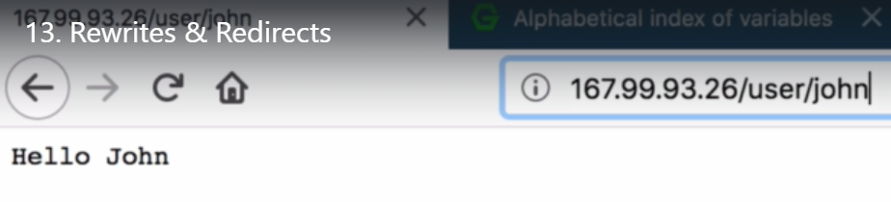

* And if we hit with some other name, then it will print **“hello user”**

